Multiple-choice section

|  |  |  |  |  |  |  |  |  |  |  |  |  |  |  |
| --- | --- | --- | --- | --- | --- | --- | --- | --- | --- | --- | --- | --- | --- | --- |
| Question | 1 | 2 | 3 | 4 | 5 | 6 | 7 | 8 | 9 | 10 | 11 | 12 | 13 | 14 |
| Answer | A | C | D | D | D | A | C | B | B | C | B | C | A | D |

Question 1 [5.1]

A

9 × p – 7 = 9p – 7

Question 2 [5.1]

C

Sum means add. Divide is the same as a fraction.



Question 3 [5.1]

D

Jasmine has m – 3, Sunil double that: 2(m – 3)

Question 4 [5.2]

D

The constant term does not contain a pronumeral.

Question 5 [5.2]

D

5m is a number multiplied by 5; n is the other number, then add 3.

Question 6 [5.6]

A

When multiplying numbers, the order does not matter so art is the same as rat.

Question 7 [5.6]

C

Collect like terms only:

7p + 11p = 18p

12 – 9 = 3

Question 8 [5.3]

B

The square root sign only applies to x.

Question 9 [5.4]

B

6 × 4 + 2 = 26

Question 10 [5.4]

C

P = 6(n – 1)  
= 6(11 – 1)  
= 60

Question 11 [5.5]

B

To add an additional shape to the pattern 6 more matchsticks are required.

m = 6s + 1

Question 12 [5.7]

C

Both x and y are negative, so (-5, -1) is in the third quadrant.

Question 13 [5.8]

A

Each y value is 8 less than its x value.

Question 14 [5.9]

D and C have the same weight.

D

Multiple-choice total marks: 14

Short answer section

Question 15 3 marks [5.7, 5.8]

(a) The ordered pair (3, 0) is located on the x-axis.

(b) The equation y = 4x + 1 is a linear relationship between the x and the y values.

(c) The point (0, 0) is the origin of the Cartesian plane.

Question 16 2 marks [5.2]

A mathematical expression consists of one or more terms connected by mathematical operations (e.g. 4f + 3g – 7).

Question 17 2 marks [5.1]

(a) The product of s and t means to multiply s and t. So, st + 10.

(b) x × x then divide by 3: 

Question 18 4 marks [5.1, 5.6]

(a) p + 4

(b) 3p

(c) p + (p + 4) + 3p = 5p + 4

Question 19 3 marks [5.1]

(a) Each chicken has two legs so we get 2p. Sheep and cows have four legs. So, the number of legs altogether is 2x + 4y + 4z.

(b) Possible pairs are x = 5 and y = 2, or  
x = 1 and y = 10 or x = 2 and y = 8 or   
x = 3 and y = 6 or x = 4 and y = 4

Question 20 2 marks [5.2]

3(x2 + )

Question 21 3 marks [5.2]

(a) Let g = the cost of a protractor and let h = the cost of a pen.

(b) 9g = 5h

Question 22 3 marks [5.2]

(a) any letter (e.g. m)

(b) 40m + 4 = 34

Question 23 5 marks [5.3]

(a) 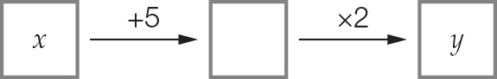

(b) y = 2(x + 5)

(c)

|  |  |  |  |  |
| --- | --- | --- | --- | --- |
| x | 4 | 5 | 6 | 10 |
| y | 18 | 20 | 22 | 30 |

Question 24 2 marks [5.3]

Divide each y value by 2 and then subtract 3.

|  |  |  |  |  |
| --- | --- | --- | --- | --- |
| x | 1 | 11 | 27 | 21 |
| y | 8 | 28 | 60 | 48 |

Question 25 5 marks [5.3]

(a) y =  (b) y = 50 – b (c) y = 3x2

Question 26 2 marks [5.3]

y = 

Question 27 4 marks [5.3]

(a)

|  |  |  |  |  |
| --- | --- | --- | --- | --- |
| Number of toys, n | 10 | 12 | 20 | 100 |
| Cost to produce the toys, C | 320 | 344 | 440 | 1400 |

(b) C = 200 + 12n

Question 28 2 marks [5.4]

(a) 4(2 + 6) = 4 × 8 = 32 True

(b) 8 × 5 – 30 = 40 – 30 = 10 False

Question 29 2 marks [5.4]

3 × = 12, 3 × = 15, 3 × = 9, 3 × = 24

|  |  |  |  |  |
| --- | --- | --- | --- | --- |
| m | 20 | 25 | 15 | 40 |
| n | 12 | 15 | 9 | 24 |

Question 30 2 marks [5.4]

d = 5 × 12 = 5 m

Question 31 6 marks [5.6]

(a)

|  |  |  |  |  |  |
| --- | --- | --- | --- | --- | --- |
| Number of shapes, S | 1 | 2 | 3 | 4 | 5 |
| Number of matches, M | 8 | 15 | 22 | 29 | 36 |

(b) M = 7S + 1

(c) M = 7 × 30 + 1 = 211

Question 32 6 marks [5.6]

(a) 42y (b) 3xy (c) 9a2 + 3

(d) -3x + 4 (e) 13p + q (f) 6m + 3n + 4

Question 33 2 marks [5.6]

(v – w) + (v – w) + (v – w) + (v – w) + (v – w) + (v – w) + (v – w) + (v – w)

= 8(v – w)

= 8v – 8w

Question 34 4 marks [5.7]

A (1, 3) B (-2, -3) C (2, 0) D (6, -2)

Question 35 8 marks [5.8]

(a)

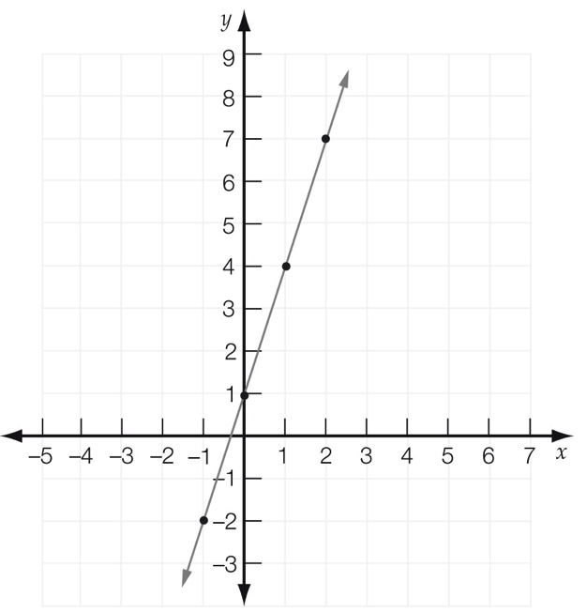

(b)

|  |  |  |  |  |
| --- | --- | --- | --- | --- |
| x | -1 | 0 | 1 | 2 |
| y | -2 | 1 | 4 | 7 |

(c) y = 3x + 1

(d) Various answers possible; (3, 10)

Question 36 3 marks [5.9]

The areas from smallest to largest are France, India and then Australia.

The populations from smallest to largest are Australia, France and then India.

A: Australia B: India C: France

Question 37 6 marks [5.9]

(a) From 3 pm until 5 pm is 2 hours.

(b) From 2 pm until 3 pm is 1 hour.  
From 5 pm until 5:10 pm is 10 minutes.  
From 6 pm until 6:30 pm is 30 minutes.  
So, total time travelling is 1 hour 40 minutes.

(c) 50 km + 50 km = 100 km

(d) 45 km in  hour is a speed of 90 km/hour.

Short answer total: 79

Extended answer section

Question 38 4 marks [5.2]

(a) E = 12m + 8n

(b) 76 = 12m + 8n Some possible values for m and n are:  
m = 1, n = 8 because 12 × 1 + 8 × 8 = 76, or  
m = 3, n = 5 because 12 × 3 + 8 × 5 = 76, or

Question 39 5 marks [5.3]

(a) 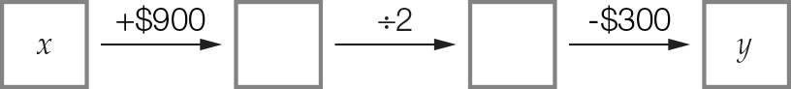

(b) y =  – 300

(c) y =  – 300  
= 3450 – 300 = 3150

Question 40 6 marks [5.4]

(a) n = 10b + 40

(b) C = 

(c) C =  = 2 cans  
n = 160 × 10 + 40 = 1640 nails

Question 41 5 marks [5.6]

(a) Fifth deposit = x + 3 + 3 + 3 + 3 = x + 12

(b) x + (x + 3) + (x + 6) + (x + 9) + (x + 12) = 5x + 30

(c) If x = 12, then 5 × 12 + 30= $90

Question 42 5 marks [5.8]

(a)–(c) (d) y = 5

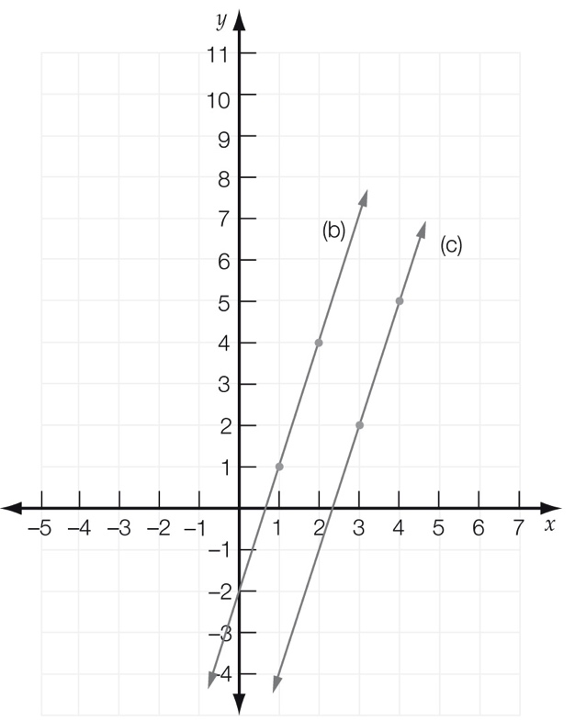

Extended answer total: 25

TOTAL test marks: 118